District of Columbia’s Person-Centered Training
Executive Summary
Creating a Person-Centered Long-Term Service and Support System

Person-centered counseling (PCC) is a key element of a No Wrong Door system. In the first year, the District focused on curriculum development and training efforts across 5 LTSS agencies – DC Office on Aging, Department of Health Care Finance, Department of Human Services, Department on Disability Services, and Department of Behavioral Health.
Project Director
Erin Leveton
Program Manager
Mark Agosto
Person-Centered Lead
Emily Price
Grant Year
Year 1
Project Development Stage
Current State Analysis
Person-Centered Commitments
-Train 2 mentor trainers, 8 Person Centered Thinking (PCT) Trainers, and 200 people on PCT
-Pilot PCT training with families that blends PCT and Supporting Families Community of Practice (CoP) Life Course elements to inform the front door design.
Outcomes
-Designed and piloted District’s Person-Centered Counseling Training Curriculum
-12 NWD PCC trainer candidates and 2 mentor candidates have been successfully trained and will conduct independent trainings
-Trained 347 staff in NWD Person-Centered Practices from 5 Core agencies and community partners.
-Designed and piloted 4-part workshop for families of people with LTSS needs.
-24 people in need of LTSS and support staff participated in PCT training. 3 became certified trainers and 3 became trainer assistants.
This required collaboration to ensure consistent messaging and promotion of person-centered thinking philosophies and trainings. Agencies reinforced the importance of attending trainings to adequately meet the needs of people and federal regulation. Concurrently, the District engaged in public outreach regarding person-centered thinking to various community stakeholders and key intake and referral sources.
The District produced a NWD Person-Centered Counseling (NWD PCC) training that was attended by over 200 learners across all of the core agencies. The Department of Behavioral Health trained an additional 145 learners with its Person-Centered Treatment Planning curriculum.

The NWD PCC curriculum builds upon the core international Learning Community for Person-Centered Practices training by emphasizing that people seeking supports and services, either for the first time or throughout the lifetime, are acknowledged for their past, present, and future experiences and contributions to their unique communities. The importance of natural supports such as family and friends whether in the recovery or long-term care model of service planning, is also a key element carried throughout the District’s training and practice guidance.

The understanding that a service system that “supports” rather than “fixes” results in a full and respected life for both people supported and their families and caregivers is another key principle of the NWD PCC training. The University of Missouri-Kansas City’s Community of Practice for Supporting Families’ LifeCourse Trajectory and Integrated Support Star reinforce this principle and offer learners methods for sharing the perspectives and supports offered by families and friends.

To provide continuing support for person-centered practices, and encourage a culture of accountability and sustainable feedback loops, the NWD team started the nation’s first Person-Centered Thinking Learning Community that includes families, people supported, and service professionals across the LTSS system. The DC Learning Community meets monthly and is divided into Committees with dedicated charters and work plans. Achievements are recorded under a designated Learning Log in order to monitor system change efforts.

To assist the core LTSS agencies in decision-making moving forward, the NWD team completed a current state of person-centered practice and training report, synthesized NWD PCC training feedback, and completed a person-centered training crosswalk that delineates the core elements of current person-centered trainings. NWD developed recommendations for continuing District wide person-centered training and to implement existing promising practices. The current state assessment was executed in three phases.
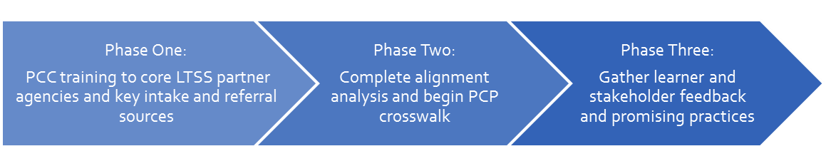
Current State of Person-Centered Trainings in the 5 core LTSS agencies:
• Person supported is a partner in all planning activities/meetings; advance notice provided
• Person supported has reasonable control over logistics (e.g., time, invitees, etc.)
• Person supported is offered a copy of Person-Centered Support Plan /Treatment Plan
• Person supported and LTSS staff is educated/prepared regarding the process and what to expect
• There is a shift in structure/roles in planning meetings with person as the focus
• Person and LTSS support staff are encouraged to capitalize on role of peers where possible
• LTSS staff must recognize the range of contributors to the planning process (e.g., peers, natural supporters)
• LTSS staff and system must understand/support rights such as self-determination
• LTSS system must value community inclusion “while,” not “after” enrolling in services (Value and recognize all points along the continuum that people may be entering or re-entering the LTSS system)
Current State of Person-Centered Practices in the 5 core LTSS agencies:
• Person-Centered questions regarding preferences and strengths are throughout current intake documents
• Person-Centered trainings are held regularly
• Train the trainer options are available across the LTSS system to keep Person-Centered training sustainable beyond the length of the No Wrong Door grant
• Person-Centered Service Plans, Recovery/Treatment Plans and Person-Centered Practices align with core Person-Centered philosophies across the LTSS system, in that it:
- involves community resources and families
- encompasses the whole person
- insists that supports are integrated and coordinated
- is based on respect, including protecting rights, encouraging self-advocacy, and eliminating discrimination
- includes access to evidence-based practices

Recommendations for on-going Person-Centered Trainings in the 5 core LTSS agencies:
- Work on a District wide Person-Centered Training that does the following:
  - Can be delivered in 1 day
  - Keeps core concepts of person-centered thinking and counseling while allows for adapted lessons per learners job function
  - Allows for various train-the-trainer options for certification
  - Includes introduction to No Wrong Door
  - Includes introduction to cultural and linguistic competency
  - Offers additional lessons for learners and trainers seeking on-going coaching
- Citywide learner management system with capacity to interface with private/community partners
- A designated point person/department to submit Continuing Education Unit requirements for professional development across professional boards
- Consider making the Person-Centered Learning Community a governing body written into policy for ongoing feedback from stakeholders
- Implement agency performance goals that support Person-Centered Trainer efforts/responsibilities
- Continue to adapt Family Planning Together training to encompasses experiences of families/caregivers across the LTSS system
- Look for opportunities for collaboration in trainings offered to Peer-to-Peer groups and the People Planning Together training
Recommendations for Person-Centered Practice Alignment Efforts:
• Consistency with strengths and interests assessments (with attention to person-centered versus system/clinical centered language)
• Consistency in assessing cultural preferences and treatment/service delivery and implications for care coordination
• Consistency in assessing family/caregiver support needs
• Consistency in assessing stage of change/readiness for change (developing action steps) in a person-centered manner
• Guidance on transitioning between service areas or out of services
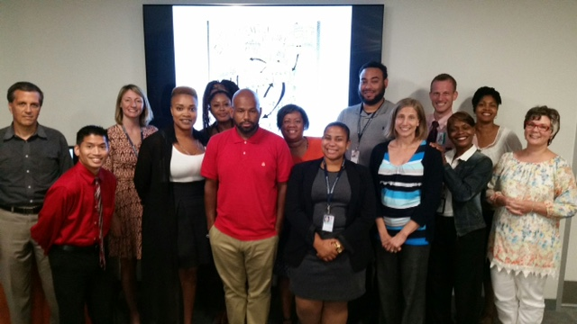
• Developing an integrated summary/person-centered description that utilizes person-centered discovery tools
No Wrong Door Person-Centered Counseling Trainer and Mentor Candidates with Supervisory Mentor.
From left to right front row: Mathew McCoullough (DD Council), Dominique Vinson (DCOA), Ali Hasan (DHCF), Linda Irizarry (DCOA), Sara Tribe Clark (DCOA), Daveena White (DDS), Tanya Richmond (SDA). From left to right back row: Shawn Terrell (ACL), Emily Price (NWD), Lourdine Jean-Francois (DCOA), Felicia Cowser (DCOA), Elbridge James (DHCF), Michael Sigelman (UCEDD), Sonya Smith (DDS).

