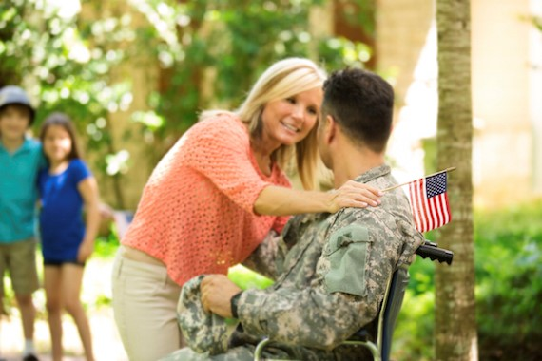
Training Resources for Veteran Caregivers

This guide aims to provide resources for caregivers who may not understand the demands of the military lifestyle but who currently find themselves caring for a Veteran.


Home Base has trained more than 18,000 healthcare professionals and community members to recognize and treat the Invisible Wounds of War. Join us and learn how you can better serve our returning Service Members and Veterans in your communities. These short, flexible, on-demand courses train healthcare professionals and first responders to better serve returning Service Members and Veterans

Serving Those Who Have Served:
Practical Approaches to Addressing the Invisible Wounds of War in Service Members and Post -9/11 Veterans

http://homebasetraining.org/Users/HomeBaseProductDetails.aspx?ActivityID=2669

Module 1: Invisible Wounds of War: PTSD (Louis Chow, PhD)
- Learn how to recognize the signs and symptoms of PTSD
- Learn how to facilitate interactions with Veterans who have PTSD

Module 2: Understanding Suicide Risk in the Military: How Can You Help? (Timothy Petersen, PhD)
- Learn the risk factors and warning signs for suicide
- Learn basic considerations for intervening with suicidal individuals

Module 3: Substance Use/Abuse in the Military (Lauren K. Richards, PhD & Louis Chow, PhD)
- Understand substance use disorder within a military context
- Learn what resources are available for Veterans and Service Members

Module 4: Invisible Wounds of War: TBI (Magda Wojtowicz, PhD)
- Learn how to recognize the signs and symptoms of TBI
- Learn how the symptoms of TBI can be mimicked or magnified by other factors

Module 5: Military Culture (Lauren K. Richards, PhD and John M. Rodolico, PhD)
- Understand the unique military experiences of Post-9/11 Service Members, the deployment cycle and reintegration difficulties
- Learn about common challenges Service Members face in seeking care for the Invisible Wounds of War

How to Access the Training:
Click on the link above > Select the red button that states CLICK HERE TO PARTICIPATE > Register for an Account, then begin your training.

Easter Seals provides free, monthly online webinars that are specific to those who are a caregiver for someone in the military or a veteran.

Take some time to view the complete archive of military caregiving webinars and downloadable materials.

You can also register for future caregiving webinars, which will allow you to ask questions in real time.

Listed below are a few samples of past webinars.



http://www.easterseals.com/explore-resources/for-caregivers/military-caregiving-webinar-1-from-daunting-to-doable.html

When you tap into your resilience, the daunting becomes doable. This hour-long webinar—the first in our bimonthly 2014 webinar series—emphasizes understanding the importance of resilience for military caregivers and presents practical ways to build resilience into their lives.



http://www.easterseals.com/explore-resources/for-caregivers/webinar-3-military-strong.html

For many military caregivers, reaching out for and accepting help may feel uncomfortable and perhaps even like accepting defeat. This one-hour session focused on strategies to overcome this tendency, recognizing one’s mastery of the thousands of caregiving tasks and honoring your military caregiver mission.



http://www.easterseals.com/explore-resources/for-caregivers/webinar-2-military-1.html

Military relationships are difficult under normal circumstances. A wound, illness or injury can significantly change your relationship. During this session, you will learn how to improve your relationship through communication, better understand each other’s needs, resolve conflict and find renewed hope. Individuals are hardwired differently and therefore can cause emotional needs to not be met in a relationship due to a lack of understanding. We will learn how to identify emotional needs and how to meet their partners' emotional needs.



http://www.easterseals.com/explore-resources/for-caregivers/webinar-7-military-and.html

Caregivers are a core part of America’s healthcare system – 5.5 million Americans support current or former Service members with a disabling injury or illness. Caregivers in rural communities face unique challenges in caring for their veterans, from the often complicated medical and mental conditions of their charges to receiving limited support from all corners of society.



http://www.easterseals.com/explore-resources/for-caregivers/webinar-10.html

2015 Military Caregiving Webinar Series presented “A Caregiver’s Guide to Unique Therapy Techniques for Women Veterans”. The webinar provided a brief overview of Posttraumatic Stress Disorder (PTSD) and Military Sexual Trauma (MST) as they relate to Women Veterans and discussion of emerging new therapy options. In addition, information regarding new therapy options, and other valuable resources for Caregivers of Women Veterans was presented.



The Caregiver Support website is designed to provide you with a wealth of information, tools and resources on family caregiving, but we know that there are times when you'd prefer to simply talk to someone.

Through VA's Caregiver Support Line and Caregiver Support Coordinators, you can find the support you need to provide the Veteran you care for with the best care at home.

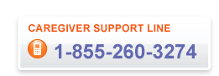

Assistance is just a quick phone call away – while you're supporting a Veteran, we're here to support you. Sometimes, the best thing to do is just talk it out. We have the support and information you need.



You may know that VA provides benefits and services for Veterans, but did you know that VA also has a number of services designed specifically to support you in your role as a Family Caregiver? VA values your commitment as a partner in our pledge to care for those who have "borne the battle," and we have several support and service options designed with you in mind.

Services include connecting with a Caregiver Support Coordinator in your area, and Peer Support for Caregivers, as well as audio recordings of the monthly education groups which provides caregivers with self-care tips and support on a variety of topics.

These support services can be found on our VA website.

Audio presentations can be found at this location.
Presentations include Choosing Your Words: Harnessing the Power of Communication, Good Grief: Finding Hope in the Necessary Losses of Being a Caregiver, and many others.

Helpful Agencies:


Vet Centers
(Provides readjustment counseling for Veterans & their families)
1461 Hooksett Road, B7
Hooksett, NH 03106
(603)668-7060

Vet Center Call Centers
(Crisis Line staffed by Combat Veterans & their families)
(877)WAR-VETS

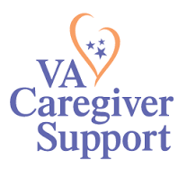
VA Caregiver Support:
www.caregiver.va.gov
VA Caregiver Support Line
1-855-260-3274

Manchester Veteran Affairs Medical Center
718 Smythe Road
Manchester, NH 03104
(603)624-4366 ext.3199|(800)892-8384

